# ONLINE PET STORE

**A Project Report**

***Submitted by***

## **Priyansha Grover**

## **Arjun Khare**

## **Akshita Singh**

***Under the Guidance of***

**Prof. Vijayetha Thoday**

***in partial fulfillment for the award of the degree of***

## **MBATech.**

**IN BRANCH OF STUDY**

## **Computer Engineering**

At

**SVKM’s NMIMS MPSTME , Mumbai**

**October 2021**



## 

## **CERTIFICATE**

This is to certify that the project entitled “Online Pet Store” is the bonafide work carried out by Priyansha Grover, Arjun Khare, Akshita Singh of MBA Tech, MPSTME (NMIMS), Mumbai, during the V semester of the academic year 2020-2021, in partial fulfillment of the requirements for the Course Web Programming.

___________________

Prof. Vijayetha Thoday Internal Mentor

_______________________ _____________________ Examiner 1 Examiner 2

## 

## **DECLARATION**

We, Priyansha Grover, Arjun Khare, Akshita Singh, Roll Nos. N015, N025, N056; MBA Tech (Computer Engineering), IV semester understand that plagiarism is defined as anyone or combination of the following:

1. Un-credited verbatim copying of individual sentences, paragraphs or illustration (such as graphs, diagrams, etc.) from any source, published or unpublished, including the internet.

2. Un-credited improper paraphrasing of pages paragraphs (changing a few words phrases, or rearranging the original sentence order)

3. Credited verbatim copying of a major portion of a paper (or thesis chapter) without clear delineation of who did write what. ( Source: IEEE, The institute, Dec. 2004)

4. I have made sure that all the ideas, expressions, graphs, diagrams, etc., that are not a result of my work, are properly credited. Long phrases or sentences that had to be used verbatim from published literature have been clearly identified using quotation marks.

5. I affirm that no portion of my work can be considered as plagiarism and I take full responsibility if such a complaint occurs. I understand fully well that the guide of the seminar/ project report may not be in a position to check for the possibility of such incidents of plagiarism in this body of work.

Signature of the Students: __________, _____________, ____________, ______________

Names: Priyansha Grover, Arjun Khare, Akshita Singh

Roll Nos. : N015, N025, N056

Place: Mumbai

Date: 20th October 2021

**ACKNOWLEDGMENTS**

We would like to thank our professor, Prof. Vijayetha Thoday for providing us with the opportunity to work on this project and their guidance. Their support in helping us develop this program and clearing our doubts has ensured that it could be prepared to the best of our abilities on time. This would have been nearly impossible without their assistance and guidance.

We are also grateful for the assistance we received from our peers to help us formulate, plan and execute the ideas for this project. Their support, in whatever form it may have been, has helped us push through and make this idea into reality.

## **TABLE OF CONTENTS**

**CHAPTER NO. TITLE PAGE NO.**

1. INTRODUCTION 6

SCOPE & PURPOSE

1. DESCRIPTION OF MODULES 8
2. SOFTWARES/API’s/DATABASE 10

DESCRIPTION

1. CODE SNIPPETs 13
2. Front end/DATABASE SCREENSHOTS 37
3. CONCLUSION & FUTURE SCOPE 45
4. APPLICATIONs IF ANY 46
5. **INTRODUCTION**

To develop a system that will allow customers to choose variety of pets from all across the world and place their order online and provide them with fast and standard services. A complete guide of the product will be available which will give the exact information regarding age, weight, diet, human imprint, history and care of the pet along with the cost respectively instead of a generic image. The software improves the working methods by replacing the existing manual system with the computer-based system.

**Ecommerce gives pet owners exactly what they want …**

* Convenience and comfort
* Product information and choice
* Pricing comparisons that make value clear
* Devoted focus on customer relationships

**WHY OUR SYSTEM IS BETTER THAN EXISTING SYSTEMS?**

* User Friendly: It will have a simple graphical interface rather than text interface.
* Will run on major platforms.
* Attractive UI design will engage the customers.
* Private Information of customers would be maintained.
* Has the option of delivery/pickup according to customer’s convenience.

**SCOPE & PURPOSE**

* To execute a user friendly and efficient web application for a Pet Store.
* To provide online accessibility and availability to users.
* To create GUI for displaying images of pets and selection of different breeds.
* The main objective of pet Shop is to enhance and upgrade the existing system by providing more far distant delivery instead of a local pet shop.
* To create navigational links that lead to adding product to cart and ultimately lead to sale of products.
* To execute entire process of acquiring and integrating the product, including aspects of branding, design, usability and function of the pet store.
* Composition of interface animation, visual element, screen layout and content in a presentable and aesthetic manner.
* Making pet stores available online, with a good UI and UX so that it enables the business to accomplish the goals.

## **DISCRIPTION OF MODULES**

The **software** used are:-

● **HTML5:** HTML5 is a markup language used for structuring and presenting the content on the World Wide Web. It is the fifth and last major HTML version.

● **Bootstrap:** Bootstrap is a front-end framework used to add layout, colour and design to the web app. Bootstrap is an HTML, CSS & JS Library that focuses on simplifying the front end development of web pages. The primary purpose of adding it to a web project is to apply Bootstrap's choices of color, size, font and layout to that project.

● **PHPMyAdmin:** phpMyAdmin Database is s software tool written in PHP, used to store the data about admin and orders. It is used to store the data about products listed on website. It is intended to handle the administration of a MySQL or MariaDB database server. You can use phpMyAdmin to perform most administration tasks, including creating a database, running queries, and adding user accounts.

● **MySQL:** MySQL is a relational database management system based on SQL – Structured Query Language. The application is used for a wide range of purposes, including data warehousing, e-commerce, and logging applications. Here it is for the purpose of a web database.

● **JavaScript:** It is a scripting language used to add dynamic behavior to the webpage and add special effects to the webpage. It is also used for validation purposes. JavaScript helps us to execute complex actions and also enables the interaction of websites with visitors. Using JavaScript, it is also possible to load the content in a document without reloading the webpage.

● **Xampp:** XAMPP is an abbreviation for cross-platform, Apache, MySQL, PHP and Perl, and is used to build site offline, on a local web server on your computer. XAMPP helps a local host or server to test its website and clients via computers and laptops before releasing it to the main server

1. **SOFTWARES/ API’s/ DATABASE**

External Interface Requirements

**User Interfaces**

Fido Fiddle has a customer user interface. Fido Fiddle has a administrator user interface. Customer user interface should have a graphical user interface (GUI). Administrator user interface should have a GUI.

**Hardware Interfaces**

No hardware interface is required for the Fido Fiddle (PETSHOP).

**Software Interfaces**

Pet shop should be a web-based system. It should be possible to open and use the website on the computers with operating systems of Windows 7, 8,10, Mac OS, Linux, Ubuntu. phpMyAdmin Database should be used to store the data about admin and orders. phpMyAdmin Database should be used to store the data about products listed on website.

**Communication Interfaces**

HTTP protocol should be used as an interface of communication between client and server sides.

**NON-FUNTIONAL REQUIREMENTS**

1) PERFORMANCE REQUIREMENTS

* + - * All the web pages generated by the system should be downloadable in short period of time over a normal internet speed (40Kbps).
      * Responses to the queries shall take no longer than 7 seconds to load onto the screen after the user submits the query.
* The system should show the confirmation message to users within 4 – 5 seconds after the user submits information to the system.

2) SECURITY REQUIREMENTS

* + - * All the network transactions that involve financial information or personally identifiable information shall be encrypted
      * The system shall permit the patrons to view only their own previously placed orders, not orders placed by other patrons

3) SOFTWARE QUALITY ATTRIBUTES

* + - * If the connection between the user and the system is broken prior to an order being either confirmed or cancelled, the system shall enable the user to recover an incomplete order

**FUNCTIONAL REQUIREMENTS**

1) USER INTERFACE

* + - * The System shall provide a help link from each displayed HTML page to explain how to use the page.

2) SOFTWARE INTERFACE

* + - * The pet system to determine whether a requested product item is available.
      * When the system notifies that a specific item from the menu is no longer available, it shall remove the product from the menu for the current date.

3) COMMUNICATION INTERFACE

* + - * The system shall send an e-mail message to the patron to confirm acceptance of an order, price, and delivery instructions.

**STAKEHOLDERS**

• Customers

• Admin

• Employees

• Suppliers/Distributers( for products listed on website)

• Investors(Pedigree, Boltz, Tetra, Orizon)

**CONSTRAINTS**

• Network Bandwidth( Due to many web requests)

## **CODE SNIPPETS**

Admin.php

<!DOCTYPE html>

<html lang="en">

<head>

    <meta charset="utf-8">

    <meta name="viewport" content="width=device-width, initial-scale=1.0">

    <meta name="description" content="">

    <meta name="author" content="">

    <link href="../images/foods/logo.png" rel="shortcut icon">

    <title>ADMIN | Petshop Online Website</title>

    <!-- core CSS -->

    <link href="css/bootstrap.css" rel="stylesheet">

    <link href="css/bootstrap.min.css" rel="stylesheet">

    <link href="css/font-awesome.min.css" rel="stylesheet">

    <link href="css/animate.min.css" rel="stylesheet">

    <link href="css/prettyPhoto.css" rel="stylesheet">

    <link href="css/main.css" rel="stylesheet">

    <link href="css/responsive.css" rel="stylesheet">

    <script src="js/jquery.js"></script>

    <script src="js/bootstrap.min.js"></script>

    <script src="js/jquery.prettyPhoto.js"></script>

    <script src="js/jquery.isotope.min.js"></script>

    <script src="js/main.js"></script>

    <script src="js/wow.min.js"></script>

<script>

$(function () {

  $('[data-toggle="tooltip"]').tooltip()

})

</script>

<script>

function printContent(el){

    var restorepage = document.body.innerHTML;

    var printcontent = document.getElementById(el).innerHTML;

    document.body.innerHTML = printcontent;

    window.print();

    document.body.innerHTML = restorepage;

}

</script>

</head><!--/head-->

<body>

     <nav class="navbar navbar-inverse" role="banner">

            <div class="container">

                <div class="navbar-header">

                    <button type="button" class="navbar-toggle" data-toggle="collapse" data-target=".navbar-collapse">

                        <span class="sr-only">Toggle navigation</span>

                        <span class="icon-bar"></span>

                        <span class="icon-bar"></span>

                        <span class="icon-bar"></span>

                    </button>

                     <a href="index.php"><h4 class="wow fadeInDown" style="margin-top:20px; color:#FFF;"><i class="fa fa-coffee"></i> Ordering Of Product</h4></a>

                </div>

                <div class="collapse navbar-collapse navbar-right">

                    <ul class="nav navbar-nav">

                        <li class="dropdown"><a class="dropdown-toggle wow fadeInDown" data-toggle="dropdown" href="#"><span class="glyphicon glyphicon-th"></span> Product <span class="caret"></span></a>

                            <ul class="dropdown-menu">

                              <li><a href="addcnp.php"> Add Product </a></li>

                              <li><a href="update_cnp.php"> Update Product </a></li>

                            </ul>

                        </li>

                        <li id="reservation" class=" active wow fadeInDown"><a href="index.php"><span class="glyphicon glyphicon-calendar"></span> Orders</a></li>

                        <li id="admin" class="wow fadeInDown"><a href="adminacc.php"><span class="glyphicon glyphicon-user"></span> Admin Account</a></li>

                        <li id="logout" class="wow fadeInDown"><a id="logoutbtn" href='<?php echo "logout_process.php?logout=1"?>'><span class="glyphicon glyphicon-share"></span> Logout</a></li>

                    </ul>

                </div>

            </div><!--/.container-->

        </nav><!--/nav-->

<br>

<div class="container">

   <form id="formFilter" name="formFilter" action="admin_reservefilter.php" method="POST" class="pull-left col-md-7 hidden-print">

        <div class="form-horizontal wow fadeInDown">

                <label for="filter" class="control-label">  <i class="glyphicon glyphicon-filter"></i> VIEW RECORDS</label>

            <div class="col-md-6">

                <select name="filter" id="filter" class="form-control">

                    <option value="New">New</option>

                    <option value="cancel">Cancel</option>

                    <option value="completed">Completed</option>

                </select>

            </div>

        </div>

    </form>

    <a href="" onClick="window.print();return false" class="btn btn-info pull-right hidden-print wow fadeInDown"><img src="images/ico/printer.ico" style="max-width: 24px; max-height: 24px;"> Print</a>

    <a href="index.php" class="btn btn-default pull-right hidden-print wow fadeInDown" style="margin-right:10px;"><img src="images/ico/refresh.png" style="max-width: 24px; max-height: 24px;"> Refresh</a>

    <div class="col-md-12" style="border: solid #D9D9D9 1px; padding: 10px; padding-top: 5px; box-shadow: #9F9F9F 2px 3px 5px; margin-top: 10px;">

        <p class="wow fadeInDown"><em>Order List</em></p>

        <table class="table table-hover table-condensed wow fadeInDown">

            <thead style="background-color:#282828; color:#fff;">

                <tr>

                    <th class="hidden-print" style="text-align:center;"> <span class="glyphicon glyphicon-exclamation-sign"></span> Status</th>

                    <th width="120px" style="text-align:center;"><span class="glyphicon glyphicon-user"></span> From </th>

                    <th style="text-align:center;"><span class="glyphicon glyphicon-gift"></span>  Product </th>

                    <th style="text-align:center;"><span class="glyphicon glyphicon-tags"></span>  Address </th>

                    <th style="text-align:center;"><span class="glyphicon glyphicon-phone"></span>  Contact </th>

                    <th style="text-align:center;"><span class="glyphicon glyphicon-time"></span> Time </th>

                </tr>

            </thead>

            <tbody id="tablebody">

               <?php include('includes/dbconn.php');

               $stat = 'new';

               $total = 0;

               $sql = ("SELECT tblcnp.*,tblorders.*

                                            FROM tblorders LEFT JOIN

                                            tblcnp ON tblorders.cnpoid = tblcnp.id WHERE tblorders.ostatus = 'New' order by tblorders.id LIMIT 0,30 ") or die (mysqli_error());

        $result=mysqli_query($con, $sql);

                if(mysqli_num_rows($result)>0){

                    while($row = mysqli_fetch_assoc($result)){

                        $total = $row['prize'] * $row['oqty'];?>

               <tr class="success" style="cursor:pointer;">

                 <td style="text-align:center;"><a href="#viewModal<?php echo $row['id']?>" data-toggle="modal" data-target="#viewModal<?php echo $row['id']?>" class="btn btn-default"><i class="glyphicon glyphicon-search"></i> View</a></td>

                <td style="text-align:center;"><?php echo $row['cname'];?></td>

                <td style="text-align:center;"><?php echo $row['name'];?></td>

                <td style="text-align:center;"><?php echo $row['address'];?></td>

                <td style="text-align:center;"><?php echo $row['contact'];?></td>

                <td style="text-align:center;"><?php echo $row['timestamp'];?></td>

               </tr>

               <!-- Modal -->

<div class="modal fade" id="viewModal<?php echo $row['id']?>" tabindex="-1" role="dialog" aria-labelledby="myModalLabel">

  <div class="modal-dialog" role="document">

    <div class="modal-content">

      <div class="modal-header">

        <button type="button" class="close" data-dismiss="modal" aria-label="Close"><span aria-hidden="true">&times;</span></button>

        <h4 class="modal-title" id="myModalLabel"><i class="glyphicon glyphicon-exclamation-sign"></i> ORDER INFORMATION</h4>

      </div>

      <form method="post" action="">

      <div class="modal-body" id="div1">

      <input type="hidden" name="fdid" value="<?php echo $row['id']?>">

        <dl class="dl-horizontal wow fadeInDown" style="text-align:left">

            <dt> Ordered:</dt>

             <dd><?php echo $row['name'].' ';?></dd>

            <dt>Description:</dt> <dd><?php echo $row['description'];?></dd>

            <dt>Price:</dt> <dd><?php echo 'Rs. '.$row['prize'];?></dd>

            <dt>Quantity:</dt> <dd><?php echo $row['oqty'];?></dd>

            <dt>Total:</dt> <dd><?php echo 'Rs. '.number_format($total,2,'.',',');?></dd>

            <hr style="border-top: 1px dashed #8c8b8b;

    border-bottom: 1px dashed #fff;">

            <h4 ><b>CUSTOMER DETAILS</b></h4>

            <dt>Ordered by:</dt> <dd><?php echo $row['cname'].' ';?></dd>

            <dt>Ordered Type:</dt> <dd><?php echo $row['otype'].' ';?></dd>

            <dt>Date Pick-up:</dt> <dd><?php echo $row['datepickup'].' ';?></dd>

            <dt>Date Order:</dt> <dd><?php echo $row['timestamp'];?></dd>

            <dt>Address:</dt> <dd><?php echo $row['address'];?></dd>

            <dt>Contact:</dt> <dd><?php echo $row['contact'];?></dd>

            <dt>Status:</dt> <dd><?php echo $row['ostatus'];?></dd>

        </dl>

      </div>

      <em style="font-size:12px;color:red; margin-left:20px;">Note: Updated Order status here</em>

      <div class="modal-footer">

        <a href="index.php" class="btn btn-default wow fadeInDown">Close</a>

        <button type="button" onClick="printContent('div1');" class="btn btn-info wow fadeInDown"><i class="glyphicon glyphicon-print"></i> Download Receipt</button>

        <button type="submit" class="btn btn-danger wow fadeInDown" name="cancel"><i class="glyphicon glyphicon-ban-circle"></i> Cancel</button>

        <button type="submit" class="btn btn-success wow fadeInDown" name="deliver"><i class="glyphicon glyphicon-send"></i> Delivered</button>

      </div>

      </form>

    </div>

  </div>

</div>

               <?php }}?>

            </tbody>

        </table>

    </div>

</div>

 <!-------------------------------------------------------OPEN MODAL MESSAGE---------------------------------------------------------------->

       <?php include('includes/dbconn.php');

       if(isset($_POST['deliver'])){

           $id = $_POST['fdid'];

           $sql =("UPDATE tblorders set ostatus = 'Completed' WHERE id = '$id'") or die (mysqli_error());

        $result=mysqli_query($con, $sql);

       if($result==true){

               header("location:index.php");}

           }

         else if(isset($_POST['cancel'])){

             $id = $_POST['fdid'];

             $sql = ("UPDATE tblorders set ostatus = 'Cancel' WHERE id = '$id'") or die (mysqli_error());

             $result=mysqli_query($con, $sql);

       if($result== true){

                 header("location:index.php");}

             }

           ?>

<br><br><br><br><br><br><br><br><br><br><br><br><br><br><br><br><br><br>

<!--*************************************************** FOOTERS **********************************************-->

    <footer id="footer" class="midnight-blue">

        <div class="container">

            <div class="row">

                <div class="col-sm-12">

                    <center>&copy;   <a target="_blank" href="#" title="#">Petshop Online Website</a></center>

                </div>

            </div>

        </div>

    </footer><!--/#footer-->

<script type="text/javascript">

    $('#filter').change(function() {

    $.post( $("#formFilter").attr("action"),

                 $("#formFilter :input").serializeArray(),

                 function(filter) {

                    //alert (filter);

                    $("#tablebody").empty();

                    $("#tablebody").html(filter);

                 });

        $("#formFilter").change( function() {

           return false;

        });

    });

</script>

</body>

</html>

Availablepackage.php

<div class="container wow fadeInDown" style=" height:500px;">

    <div class="col-md-12" style="border: solid #D9D9D9 1px; padding: 10px; padding-top: 5px; box-shadow: #9F9F9F 2px 3px 5px; margin-top: 10px;">

        <div class="panel panel-success">

            <div class="panel-heading panel-title" >

                <span style="font-weight:bold; font-family:verdana;"><i class="glyphicon glyphicon-cog"></i> Product </span>

            </div>

            <div class="panel-body" style="background-color:#fff;">

            <div class="col-lg-3">

            <em style="color:red;">Note: Fields with (*) are required</em></div>

            <div class="col-lg-6">

                <form class="form-horizontal" action="" method="post" enctype="multipart/form-data">

                    <table>

                        <tr>

                            <td style="text-align:right; font-weight:bold;">Product name* : &emsp;</td>

                            <td style="text-align:center;">&emsp; <textarea class="form-control" name="cnpname" required></textarea></td>

                        </tr>

                        <tr>

                            <td style="text-align:right;font-weight:bold;">Amount* : &emsp;</td>

                            <td style="text-align:center;">&emsp; <input type="number" step="any" class="form-control" name="prize" placeholder="0.00" required /></td>

                        </tr>

                        <tr>

                            <td style="text-align:right;font-weight:bold;">Description* : &emsp;</td>

                            <td style="text-align:center;">&emsp; <textarea class="form-control" name="des" required></textarea></td>

                        </tr>

                         <tr>

                            <td style="text-align:right;font-weight:bold;">Image* : &emsp;</td>

                            <td style="text-align:center;">&emsp; <input type="file" name="image" required /></td>

                        </tr>

                         <tr>

                            <td style="text-align:right;font-weight:bold;">Status* : &emsp;</td>

                            <td style="text-align:center;">&emsp; <select name="stat" class="form-control">

                                                <option>Select</option>

                                                <option value="Available">Available</option>

                                                <option value="Un-Available">Un-Available</option>

                            </select></td>

                        </tr>

                         <tr style="margin-top:20px;">

                            <td style="text-align:right;font-weight:bold;" colspan="2"><br /><p></p>

                            <button class="btn btn-default" type="clear">Clear</button>

                            <button class="btn btn-success" type="submit" name="save">Save</button></td>

                        </tr>

                    </table>

                </form>

            </div>

            <div class="col-lg-3"></div>

            </div>

        </div>

    </div>

</div>

<?php

include('includes/dbconn.php');

if(isset($_POST['save'])){

            $name = $_POST['cnpname'];

            $prize = $_POST['prize'];

            $des = $_POST['des'];

            $stat = $_POST['stat'];

             //image

                                $image = addslashes(file_get_contents($_FILES['image']['tmp_name']));

                                $image_name = addslashes($_FILES['image']['name']);

                                $image_size = getimagesize($_FILES['image']['tmp_name']);

//

                                move_uploaded_file($_FILES["image"]["tmp_name"], "images/" . $_FILES["image"]["name"]);

                                $location = "images/" . $_FILES["image"]["name"];

            if(empty($name) || empty($prize) || empty($des) || empty($stat)){

                    echo '<script>alert("Fields must be empty.");

                                 window.location.href="addcnp.php";

                    </script>';

                }else {

                    $sql = ("INSERT INTO tblcnp VALUES(NULL,'$name','$prize','$des','$location','$stat')") or die (mysql_error());

                    $result=mysqli_query($con, $sql);

                    if($result==true){

                        echo '<script>alert("Save Successfully!");

                                    window.location.href="addcnp.php";</script>';}else {

                                        echo '<script>alert("Sory unable to process your request!");

                                    window.location.href="addcnp.php";</script>';

                                        }

                    }

        }

?>

Dbconn.php

<?php

/* Database config */

$db_host        = 'localhost';

$db_user        = 'root';

$db_pass        = '';

$db_database    = 'dbcnp';

/* End config */

$con = mysqli_connect($db_host, $db_user, $db_pass, $db_database);

// Check connection

if (!$con) {

    die("Connection failed: " . mysqli_connect_error());

}

Footer.php

<footer id="footer" class="midnight-blue wow fadeInDown ">

        <div class="container">

            <div class="row">

                <div class="col-sm-6 wow fadeInDown">

               &copy; <a target="_blank" href="#" title="#">Petshop Online Website</a>.

                </div>

                <div class="col-sm-6">

                    <ul class="pull-right wow fadeInDown">

                        <li class="wow fadeInDown"><a href="index.php"><i class="fa fa-home"></i> Home</a></li>

                        <li class="wow fadeInDown"><a href="contacts.php"><i class="fa fa-phone"></i> Contacts</a></li>

                        <li class="wow fadeInDown"><a href="#loginModal" data-toggle="modal" data-target="#loginModal"><i class="fa fa-lock"></i> Admin</a></li>

                    </ul>

                </div>

            </div>

        </div>

    </footer><!--/#footer-->

Header.php

<!DOCTYPE html>

<html lang="en">

<head>

    <meta charset="utf-8">

    <meta name="viewport" content="width=device-width, initial-scale=1.0">

    <meta name="description" content="">

    <meta name="author" content="">

    <link href="images/foods/logo.png" rel="shortcut icon">

    <title>Online Petshop Website</title>

    <!-- core CSS -->

    <link href="css/bootstrap.css" rel="stylesheet">

    <link href="css/bootstrap.min.css" rel="stylesheet">

    <link href="css/font-awesome.min.css" rel="stylesheet">

    <link href="css/animate.min.css" rel="stylesheet">

    <link href="css/prettyPhoto.css" rel="stylesheet">

    <link href="css/main.css" rel="stylesheet">

    <link href="css/responsive.css" rel="stylesheet">

</head><!--/head-->

<!--*********************************************START OF NAVIGATION BAR****************************************-->

<body>

      <nav class="navbar navbar-inverse" role="banner">

            <div class="container">

                <div class="navbar-header">

                    <button type="button" class="navbar-toggle" data-toggle="collapse" data-target=".navbar-collapse">

                        <span class="sr-only">Toggle navigation</span>

                        <span class="icon-bar"></span>

                        <span class="icon-bar"></span>

                        <span class="icon-bar"></span>

                    </button>

                </div>

                 <a href="index.php"><h5 class="wow fadeInDown" style="margin-top:20px; color:#FFF;"><img src="images/logo.jpg"  width="15% "/> Sweet and healthy cakes</h5></a>

                <div class="collapse navbar-collapse navbar-right wow fadeInDown">

                    <ul class="nav navbar-nav">

                         <li><a href="index.php"><i class="fa fa-home"></i>Home</a></li>

                        <li ><a href="about-us.php">About Us</a></li>

                        <li><a href="available.php">Availables</a></li>

                        <li><a href="contacts.php">Contacts</a></li>

                        <li>

                        <a data-toggle="modal" data-target=".bs-example-modal-sm" style="cursor:pointer;">Admin</a>

                        </li>

                    </ul>

                </div>

            </div><!--/.container-->

        </nav><!--/nav-->

Updatesavailable.php

            <div class="col-md-12" style="background-color:#fff; border: solid #D9D9D9 1px; padding: 10px; padding-top: 5px; box-shadow: #9F9F9F 2px 3px 5px; margin-top: 10px; height:700px;">

        <div class="panel panel-primary">

            <div class="panel-heading panel-title text-center wow fadeInDown">

                <span style="font-weight:bold; font-family:verdana;"><i class="glyphicon glyphicon-list-alt"></i> Product List</span>

            </div>

            <div class="panel-body" style="background-color:#fff;">

                 <!--   Basic Table  -->

              <table class="table table-responsive table-hover table-bordered table-condensed table-striped wow fadeInDown" width="100%">

                <thead>

                    <tr style="background-color:#000; color:#FFF;">

                        <td style="text-align:center; width:auto;" class="wow fadeInDown">NAME</td>

                        <td style="text-align:center; width:auto;" class="wow fadeInDown">DESCRIPTION</td>

                        <td style="text-align:center; width:auto;" class="wow fadeInDown">PRICE</td>

                        <td style="text-align:center; width:auto;" class="wow fadeInDown">STATUS</td>

                        <td style="text-align:center; width:auto;" class="wow fadeInDown">ACTION</td>

                    </tr>

                    <tbody>

                    <?php include('includes/dbconn.php');

                    $id = 0;

                    $sql = ("SELECT *  FROM tblcnp order by id DESC") or die (mysqli_error());

                    $result=mysqli_query($con, $sql);

                    if(mysqli_num_rows($result)>0){

                        while($row = mysqli_fetch_assoc($result)){

                            $id = $row['id'];

                            $name = $row['name'];

                            $des = $row['description'];

                            $prize = $row['prize'];

                            $stat = $row['status'];

                            $image = $row['image'];?>

                        <tr style="font-size:16px; cursor:pointer;">

                            <td class="wow fadeInDown"> <center><strong><?php echo $row['name'];?></strong></center></td>

                            <td class="wow fadeInDown"> <center><strong><?php echo $row['description'];?></strong></center></td>

                            <td class="wow fadeInDown"> <center><strong><?php echo $row['prize'];?></strong></center></td>

                            <td class="wow fadeInDown"> <center><strong><?php echo $row['status'];?></strong></center></td>

                            <td class="wow fadeInDown"><center><a href="#updateModal<?php echo $id;?>" data-toggle="modal" data-target="#updateModal<?php echo $id;?>" class="btn btn-default">Update</a> | <a href="#deleteModal<?php echo $id;?>" data-toggle="modal" data-target="#deleteModal<?php echo $id;?>" class="btn btn-danger"> Delete</a></center></td>

                        </tr>

                       <?php include('updateModal.php')?>

                       <?php include('deleteModal.php')?>

                        <?php }}?>

                    </tbody>

                </thead>

              </table>

                  <!-- End  Basic Table  -->

        </div>

    </div>

</div>

Index.php

<?php

    session_start();

    if (!isset($_SESSION['username'])){

?>

<!DOCTYPE html>

<html lang="en">

<head>

    <meta charset="utf-8">

    <meta name="viewport" content="width=device-width, initial-scale=1.0">

    <meta name="description" content="">

    <meta name="author" content="">

<!--    <link href="images/logo.jpg" rel="shortcut icon"> -->

    <title>Petshop Online Website</title>

    <script src="https://kit.fontawesome.com/420415cd2e.js" crossorigin="anonymous"></script>

  <!-- core CSS -->

    <link href="css/bootstrap.css" rel="stylesheet">

    <link href="css/bootstrap.min.css" rel="stylesheet">

    <link href="css/font-awesome.min.css" rel="stylesheet">

    <link href="css/animate.min.css" rel="stylesheet">

    <link href="css/prettyPhoto.css" rel="stylesheet">

    <link href="css/main.css" rel="stylesheet">

    <link href="css/responsive.css" rel="stylesheet">

</head><!--/head-->

<!--*********************************************START OF NAVIGATION BAR****************************************-->

<body>

<nav class="navbar navbar-inverse" role="banner">

            <div class="container">

                <div class="navbar-header">

                    <button type="button" class="navbar-toggle" data-toggle="collapse" data-target=".navbar-collapse">

                        <span class="sr-only">Toggle navigation</span>

                        <span class="icon-bar"></span>

                        <span class="icon-bar"></span>

                        <span class="icon-bar"></span>

                    </button>

                    <a href="index.php" style="display:flex;justify-content:center;align-items:center">

                        <h4  class="wow fadeInDown" style=" color:#FFF;font-size:2em">

                        <i class="fas fa-paw" style="color:#8A8A00;"></i>    Fido Fiddle</h4>

                    </a>

                </div>

                <div class="collapse navbar-collapse navbar-right wow fadeInDown" style="display:flex;justify-content:center;align-items:center">

                    <ul class="nav navbar-nav" style=" color:#FFF;font-size:1.2em">

                        <li class="active"><a href="index.php"><i class="fa fa-home" style="margin-right:0.5rem"></i>Home</a></li>

                        <li ><a href="about-us.php">About Us</a></li>

                        <li><a href="available.php">Available Products</a></li>

                        <li><a href="contacts.php">Contacts</a></li>

                    </ul>

                </div>

            </div>

            <!--/.container-->

        </nav>

        <!--/nav-->

<!--*********************************************START SLIDER************************************************-->

<div class="container-fluid">

    <br>

        <div class="col-md-9 wow fadeInDown">

            <div id="carousel-example-generic" class="carousel slide" data-ride="carousel">

              <!-- Indicators -->

              <ol class="carousel-indicators">

                <li data-target="#carousel-example-generic" data-slide-to="0" class="active"></li>

                <li data-target="#carousel-example-generic" data-slide-to="1"></li>

                <li data-target="#carousel-example-generic" data-slide-to="2"></li>

                <li data-target="#carousel-example-generic" data-slide-to="3"></li>

              </ol>

              <!-- Wrapper for slides -->

              <div class="">

                <div class="">

                  <img src="images/main.jpg" alt="" class="">

                </div>

              </div>

              <!-- Controls -->

            </div>

<!--*********************************************Food PACKAGES************************************************-->

            </div>

        <div class="col-md-3" >

            <div class="panel panel-default wow fadeInDown">

              <!-- Default panel contents -->

              <div class="panel-heading wow fadeInDown" style="font-weight:bold; font-size:16px; color:#36648B;">Welcome To Our Petshop<br> <i class="glyphicon glyphicon-calendar"></i> <?php echo date('M d, Y');?></div>

            </div>

            <div class="panel panel-default wow fadeInDown">

              <!-- Default panel contents -->

              <div class="panel-heading wow fadeInDown" style="font-weight:bold; font-size:16px; color:#36648B;">Petshop On Special Offer </div>

              <ul class="list-group">

                <li class="list-group-item wow fadeInDown">Dog - <span style="color:#8B8B00; font-weight:bold;">Rs.5000 to Rs.60,000 </span> <span style="color:#EE5C42;" class="glyphicon glyphicon-ok pull-right"></span></li>

                 <li class="list-group-item wow fadeInDown">Fish  - <span style="color:#8B8B00; font-weight:bold;">Rs.80 to Rs.7000 </span> <span style="color:#EE5C42;" class="glyphicon glyphicon-ok pull-right"></span></li>

                  <li class="list-group-item wow fadeInDown">Bird  - <span style="color:#8B8B00; font-weight:bold;">Rs.1000 to Rs.10,000 </span> <span style="color:#EE5C42;" class="glyphicon glyphicon-ok pull-right"></span></li>

                  <li class="list-group-item wow fadeInDown">Cat- <span style="color:#8B8B00; font-weight:bold;">Rs.4000 to Rs.40,000 </span> <span style="color:#EE5C42;" class="glyphicon glyphicon-ok pull-right"></span></li>

              </ul>

              <a href="available.php" class="btn btn-success btn-sm pull-right wow fadeInDown">Click here to View More</a>

            </div>

            <br>

                <div class="panel panel-default wow fadeInDown">

                    <div class="panel-heading wow fadeInDown" style="font-size:16px; font-weight:bold; color: #36648B;">Our Location</div>

                </div>

                    <div class="recent-work-wrap class="wow fadeInDown"">

                        <img class="img-responsive wow fadeInDown" src="images/map.jpg" alt="">

                            <div class="recent-work-inner">

                                <a class="preview wow fadeInDown" href="images/map1.jpg" rel="prettyPhoto"><br><span class="btn btn-success btm-sm pull-right">Preview Map</span></a>

                            </div>

                    </div>

                </div>

        </div>

</div><!--/.container-->

<br><br>

<!--*************************************************** FOOTERS **********************************************-->

<footer id="footer" class="midnight-blue wow fadeInDown">

        <div class="container">

            <div class="row">

                <div class="col-sm-6 wow fadeInDown">

               &copy; <a target="_blank" href="#" title="#">Petshop Online Website</a>.

                </div>

                <div class="col-sm-6">

                    <ul class="pull-right wow fadeInDown">

                        <li class="wow fadeInDown"><a href="index.php"><i class="fa fa-home"></i> Home</a></li>

                        <li class="wow fadeInDown"><a href="contacts.php"><i class="fa fa-phone"></i> Contacts</a></li>

                        <li class="wow fadeInDown"><a href="#loginModal" data-toggle="modal" data-target="#loginModal"><i class="fa fa-lock"></i> Admin</a></li>

                    </ul>

                </div>

            </div>

        </div>

    </footer><!--/#footer-->

 <!----loginModal----->

<?php include('loginModal.php');?>

    <script src="js/jquery.js"></script>

    <script src="js/bootstrap.min.js"></script>

    <script src="js/jquery.prettyPhoto.js"></script>

    <script src="js/jquery.isotope.min.js"></script>

    <script src="js/main.js"></script>

    <script src="js/wow.min.js"></script>

</body>

</html>

<?php

} else if(isset($_SESSION['username'])) {

    include('includes/admin.php');

} ?>

Loginmodal.php

   <div class="modal fade bs-example-modal-sm" id="loginModal"tabindex="-1" role="dialog" aria-labelledby="mySmallModalLabel" aria-hidden="true">

                              <div class="modal-dialog modal-sm">

                                <div class="modal-content wow fadeInDown">

                                <div class="modal-header">

                               <h4 class="wow fadeInDown"> Petshop Online Website</h4>

                                </div>

                               <br />

                               <center><i class="fa fa-user"></i> Welcome Admin</center>

                                <form class="form-horizontal wow fadeInDown" method="POST" action="adminlogin_process.php">

                                        <div class="form-group">

                                            <label for="name" class="col-sm-4 control-label wow fadeInDown">Username</label>

                                            <div class="col-sm-6">

                                                <input type="text" class="form-control wow fadeInDown" id="name" name="username" placeholder="Enter Username" onKeyPress="return isNotAlphanumeric(event)" required />

                                            </div>

                                        </div>

                                        <div class="form-group">

                                            <label for="name" class="col-sm-4 control-label wow fadeInDown">Password</label>

                                            <div class="col-sm-6">

                                                <input type="password" class="form-control wow fadeInDown" id="name" name="password" placeholder="Enter Password" onKeyPress="return isNotAlphanumeric(event)" required>

                                            </div>

                                        </div>

                                            <div class="modal-footer wow fadeInDown" style="padding-right:110px;">

                                                <button type="submit" class="btn btn-info wow fadeInDown"><span class="glyphicon glyphicon-log-in"></span> Login</button>

                                                 <button type="reset" class="btn btn-default wow fadeInDown">Clear</button>

                                                <button type="button" class="btn btn-danger wow fadeInDown" data-dismiss="modal">Close</button>

                                        </div>

                                  </form>

                                </div>

                              </div>

                            </div>

Available.php

<?php

session_start();

if (!isset($_SESSION['username'])) {

?>

    <!DOCTYPE html>

    <html lang="en">

    <head>

        <meta charset="utf-8">

        <meta name="viewport" content="width=device-width, initial-scale=1.0">

        <meta name="description" content="">

        <meta name="author" content="">

        <!--    <link href="images/logo.jpg" rel="shortcut icon"> -->

        <title>Petshop Online Website</title>

        <script src="https://kit.fontawesome.com/420415cd2e.js" crossorigin="anonymous"></script>

        <!-- core CSS -->

        <link href="css/bootstrap.css" rel="stylesheet">

        <link href="css/bootstrap.min.css" rel="stylesheet">

        <link href="css/font-awesome.min.css" rel="stylesheet">

        <link href="css/animate.min.css" rel="stylesheet">

        <link href="css/prettyPhoto.css" rel="stylesheet">

        <link href="css/main.css" rel="stylesheet">

        <link href="css/responsive.css" rel="stylesheet">

    </head>

    <!--/head-->

    <!--*********************************************START OF NAVIGATION BAR****************************************-->

    <body>

        <nav class="navbar navbar-inverse" role="banner">

            <div class="container">

                <div class="navbar-header">

                    <button type="button" class="navbar-toggle" data-toggle="collapse" data-target=".navbar-collapse">

                        <span class="sr-only">Toggle navigation</span>

                        <span class="icon-bar"></span>

                        <span class="icon-bar"></span>

                        <span class="icon-bar"></span>

                    </button>

                    <a href="index.php" style="display:flex;justify-content:center;align-items:center">

                        <h4 class="wow fadeInDown" style=" color:#FFF;font-size:2em">

                            <i class="fas fa-paw" style="color:#8A8A00;"></i> Fido Fiddle</h4>

                    </a>

                </div>

                <div class="collapse navbar-collapse navbar-right wow fadeInDown" style="display:flex;justify-content:center;align-items:center">

                    <ul class="nav navbar-nav" style=" color:#FFF;font-size:1.2em">

                        <li><a href="index.php"><i class="fa fa-home" style="margin-right:0.5rem"></i>Home</a></li>

                        <li><a href="about-us.php">About Us</a></li>

                        <li class="active"><a href="available.php">Available Products</a></li>

                        <li><a href="contacts.php">Contacts</a></li>

                    </ul>

                </div>

            </div>

            <!--/.container-->

        </nav>

        <!--/nav-->

        <!--*********************************************START OF Availables************************************************-->

        <section id="tour-packages" class="center wow fadeInDown">

            <div style="font-size:30px; font-family:verdana; font-weight:bold; color: #8B8B00; text-align:center;">Product</div>

            <p style="text-align:center; font-family:verdana;"><br></p>

            <div class="container" style="height:400px;">

                <iframe src="availableframe.php" width="100%;" height="400px;" style="border-style:none;"></iframe>

            </div>

            </div>

        </section>

        <!--*************************************************** FOOTERS **********************************************-->

        <?php include('includes/footer.php'); ?>

        <!----------loginModal----------->

        <?php include('loginModal.php') ?>

        <script src="js/jquery.js"></script>

        <script src="js/bootstrap.min.js"></script>

        <script src="js/jquery.prettyPhoto.js"></script>

        <script src="js/jquery.isotope.min.js"></script>

        <script src="js/main.js"></script>

        <script src="js/wow.min.js"></script>

    </body>

    </html>

<?php

} else if (isset($_SESSION['username'])) {

    include('includes/admin.php');

} ?>

Dbcnp.sql

SET SQL_MODE = "NO_AUTO_VALUE_ON_ZERO";

SET time_zone = "+00:00";

CREATE TABLE IF NOT EXISTS `admininfo` (

`id` int(11) NOT NULL,

  `name` varchar(50) DEFAULT NULL,

  `contact` varchar(50) DEFAULT NULL,

  `email` varchar(50) DEFAULT NULL,

  `username` varchar(50) DEFAULT NULL,

  `password` varchar(50) DEFAULT NULL

) ENGINE=InnoDB AUTO_INCREMENT=2 DEFAULT CHARSET=latin1;

INSERT INTO `admininfo` (`id`, `name`, `contact`, `email`, `username`, `password`) VALUES

(1, 'Akshita Singh', '9930839140', 'akshitakawar1228@gmail.com', 'petshop', 'akshita01');

CREATE TABLE IF NOT EXISTS `tblcnp` (

`id` int(11) NOT NULL,

  `name` varchar(50) DEFAULT NULL,

  `prize` float DEFAULT NULL,

  `description` varchar(50) DEFAULT NULL,

  `image` varchar(250) DEFAULT NULL,

  `status` varchar(50) DEFAULT NULL

) ENGINE=InnoDB AUTO_INCREMENT=6 DEFAULT CHARSET=latin1;

INSERT INTO `tblcnp` (`id`, `name`, `prize`, `description`, `image`, `status`) VALUES

(1, 'Baltimore Oriole', 350, 'The rich, whistling song of the Baltimore Oriole, ', 'images/e.jpg', 'Available'),

(2, 'Maltese', 500, 'A dog breed whoâ€™s gentle and fearless, the Malte', 'images/2.jpg', 'Available'),

(3, 'Bulldog', 550, 'Bulldogs originally were used to drive cattle to m', 'images/3.jpg', 'Available'),

(4, 'Gordon Setter', 600, 'The Gordon Setter, the black avenger of the Highla', 'images/5.jpg', 'Available'),

(5, 'Bedlington Terrier', 500, 'Bedlingtons are lithe, energetic Englishmen. The c', 'images/9.JPG', 'Available');

CREATE TABLE IF NOT EXISTS `tblorders` (

`id` int(11) NOT NULL,

  `cname` varchar(50) DEFAULT NULL,

  `address` varchar(100) DEFAULT NULL,

  `contact` varchar(50) DEFAULT NULL,

  `cnpoid` int(11) DEFAULT NULL,

  `oqty` int(11) DEFAULT NULL,

  `ostatus` varchar(50) DEFAULT NULL,

  `timestamp` timestamp NOT NULL DEFAULT CURRENT_TIMESTAMP ON UPDATE CURRENT_TIMESTAMP,

  `otype` varchar(50) DEFAULT NULL,

  `datepickup` date DEFAULT NULL

) ENGINE=InnoDB AUTO_INCREMENT=15 DEFAULT CHARSET=latin1;

INSERT INTO `tblorders` (`id`, `cname`, `address`, `contact`, `cnpoid`, `oqty`, `ostatus`, `timestamp`, `otype`, `datepickup`) VALUES

(10, 'Jeancen Sayoc', 'Tacloban City', '09369420867', 4, 1, 'new', '2016-10-13 15:09:46', 'Pick-up', '2016-10-14'),

(11, 'Jhazel Dela Cruz', 'Kabankalan City', '09095744586', 3, 3, 'new', '2019-03-17 23:15:46', 'Pick-up', '2019-03-18'),

(12, 'Jhazel Dela Cruz', 'kabfsheth', '14253', 5, 3, 'new', '2019-03-18 02:00:16', 'Pick-up', '0000-00-00'),

(13, 'dsgreer', 'xghre', '45744', 5, 4, 'new', '2019-03-18 02:21:14', 'Deliver', '0000-00-00');

ALTER TABLE `admininfo`

 ADD PRIMARY KEY (`id`);

ALTER TABLE `tblcnp`

 ADD PRIMARY KEY (`id`);

ALTER TABLE `tblorders`

 ADD PRIMARY KEY (`id`);

ALTER TABLE `admininfo`

MODIFY `id` int(11) NOT NULL AUTO_INCREMENT,AUTO_INCREMENT=2;

ALTER TABLE `tblcnp`

MODIFY `id` int(11) NOT NULL AUTO_INCREMENT,AUTO_INCREMENT=6;

ALTER TABLE `tblorders`

MODIFY `id` int(11) NOT NULL AUTO_INCREMENT,AUTO_INCREMENT=15;

1. **Front end/ Database Screenshots**

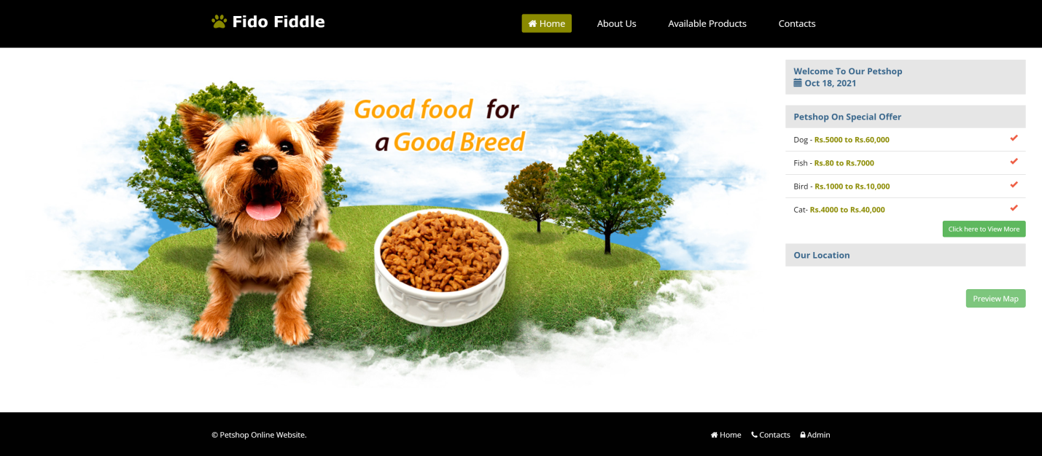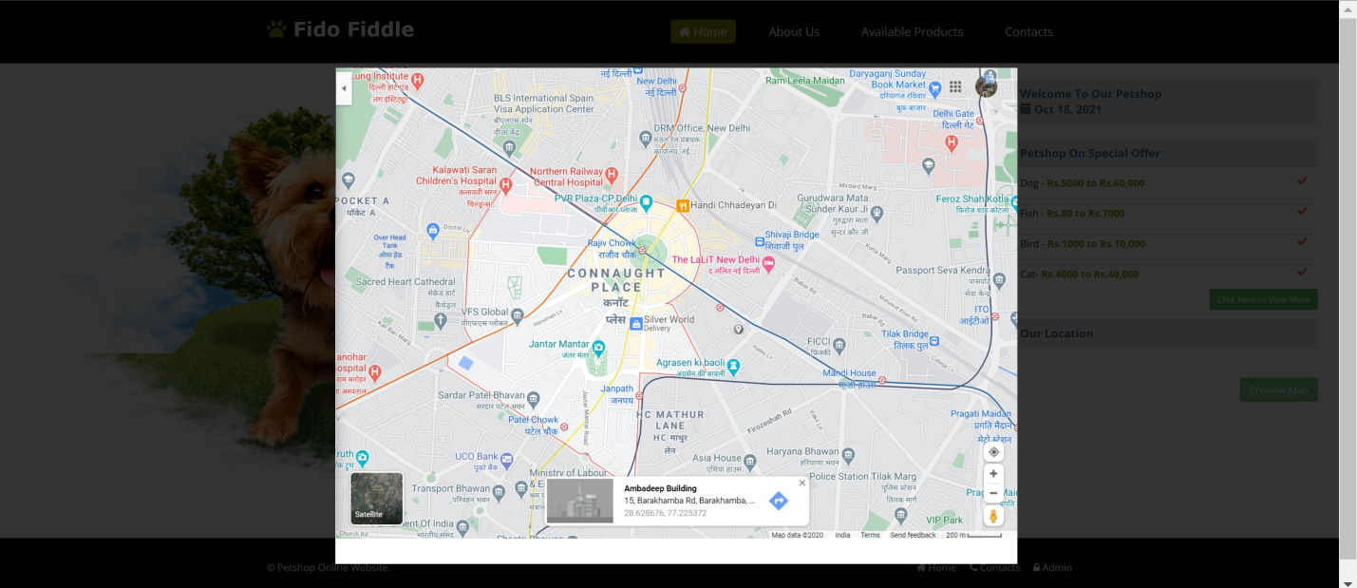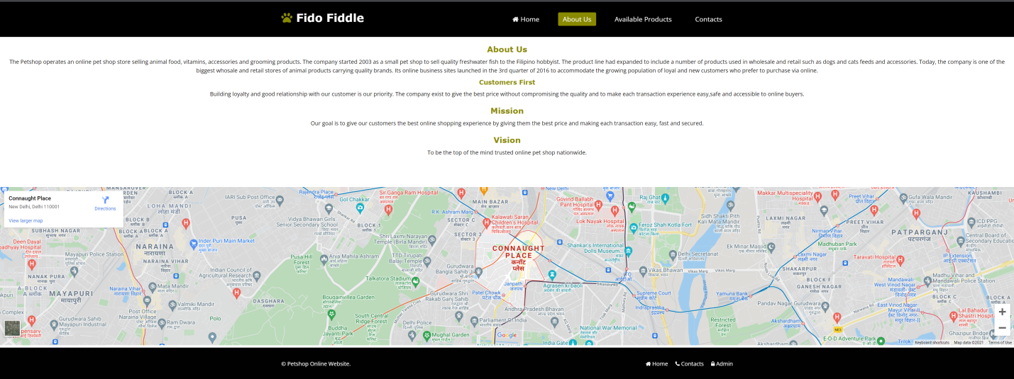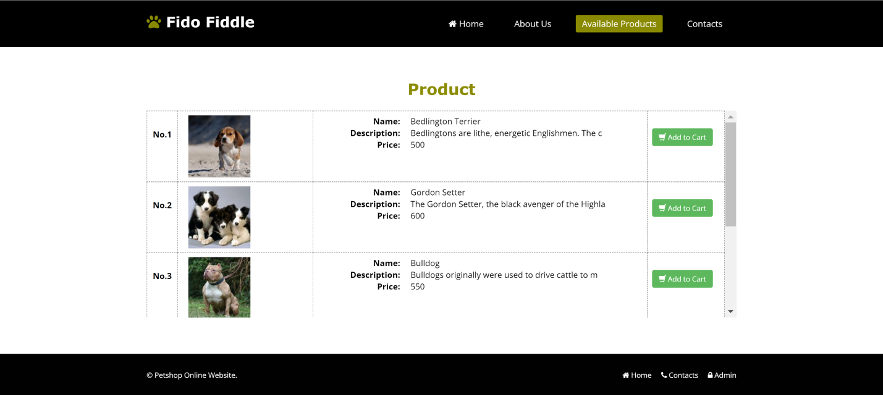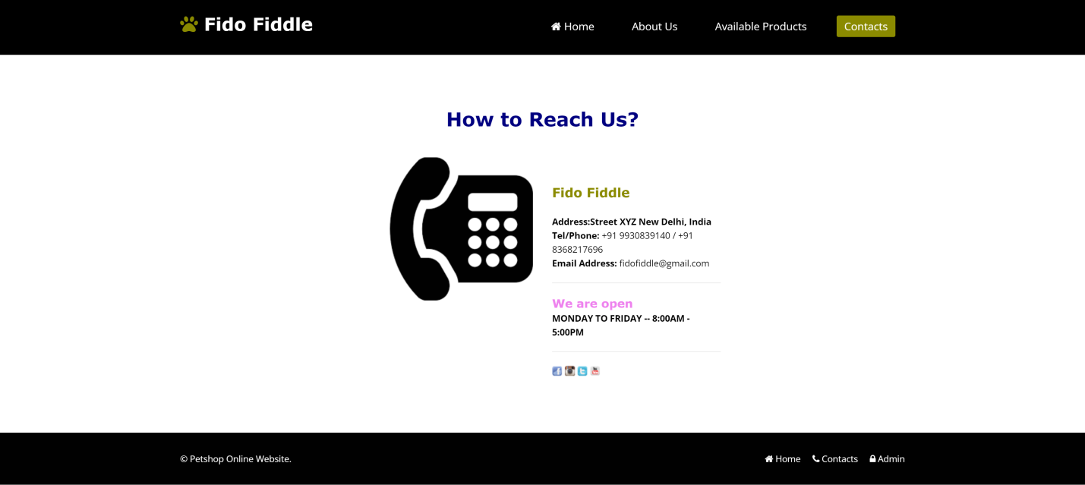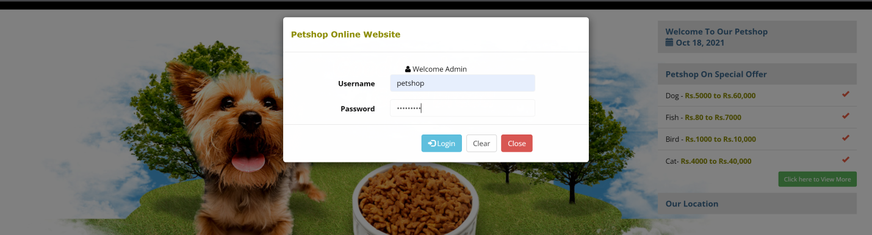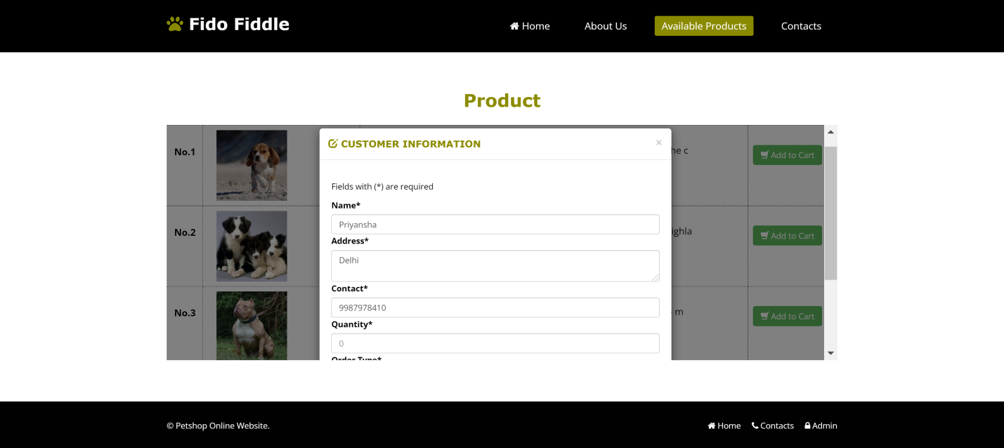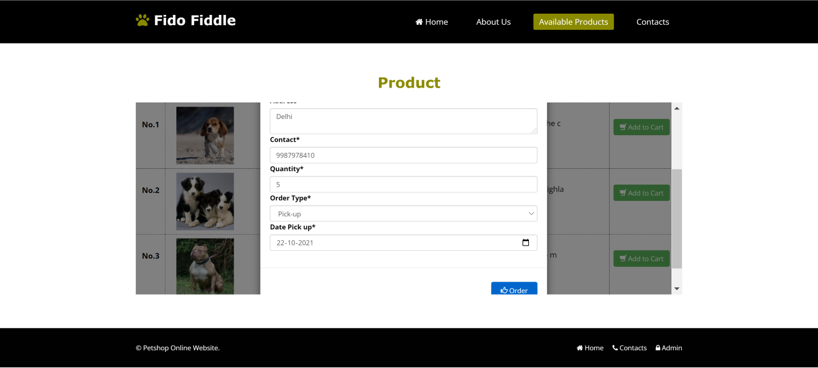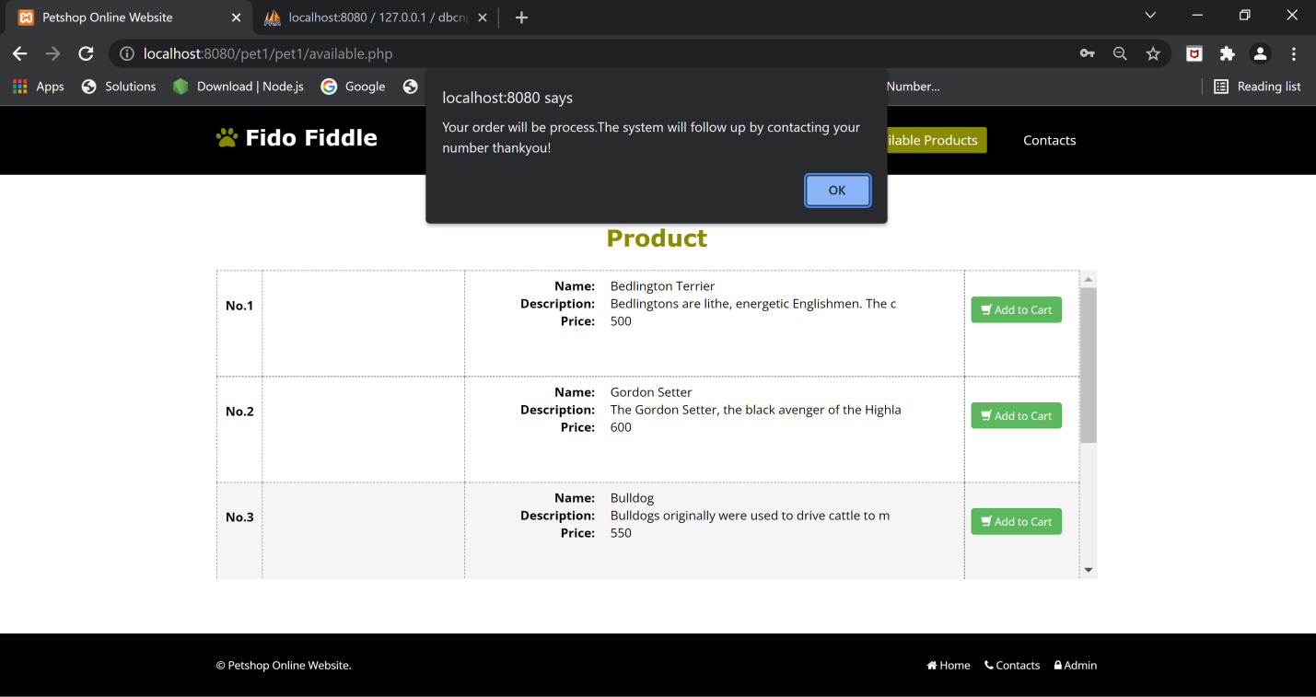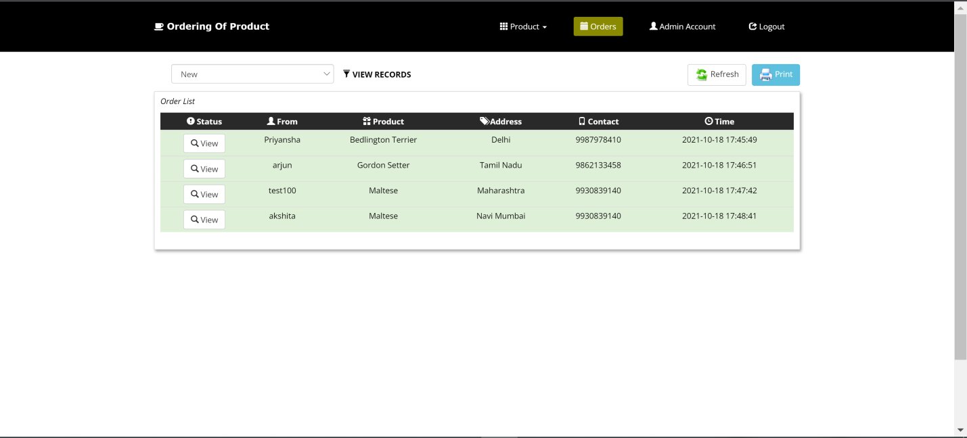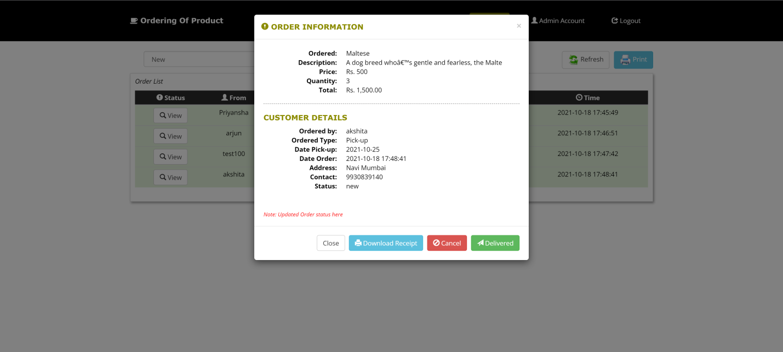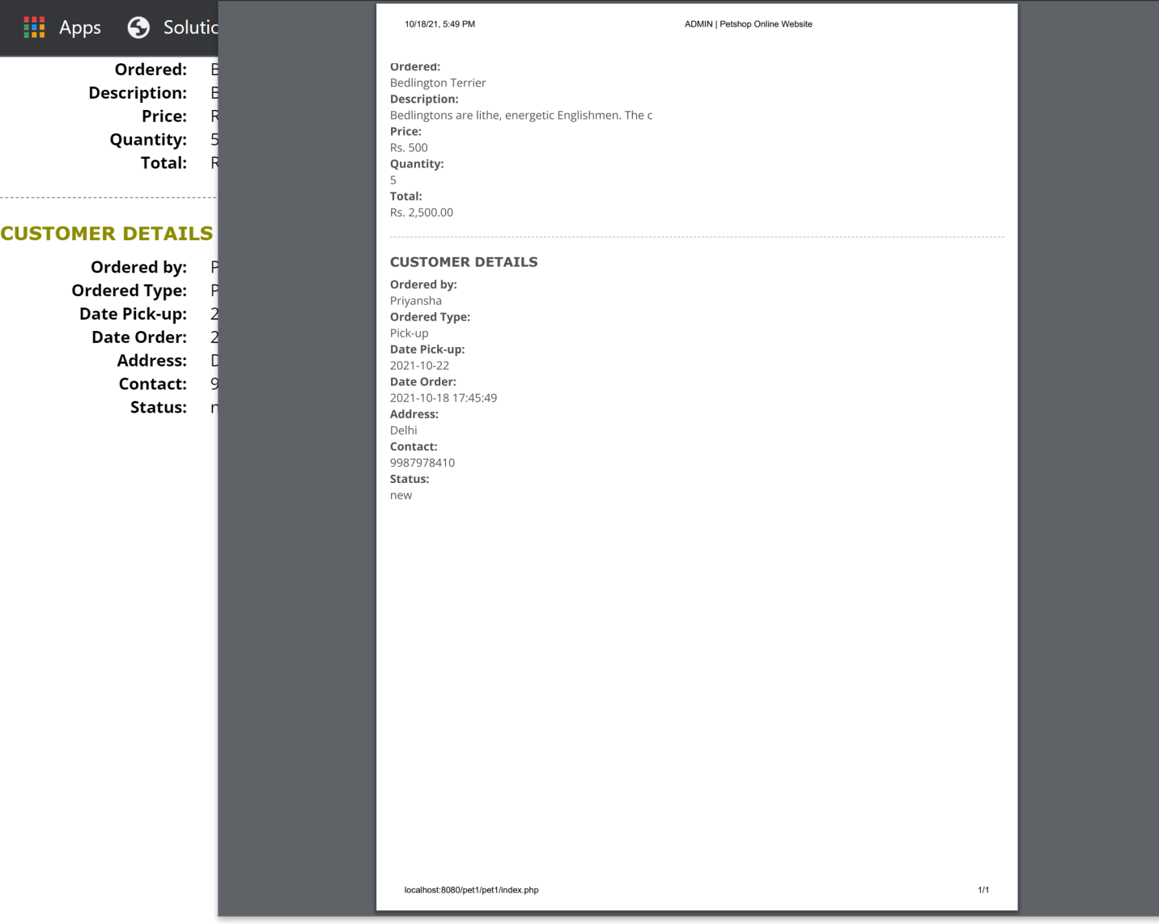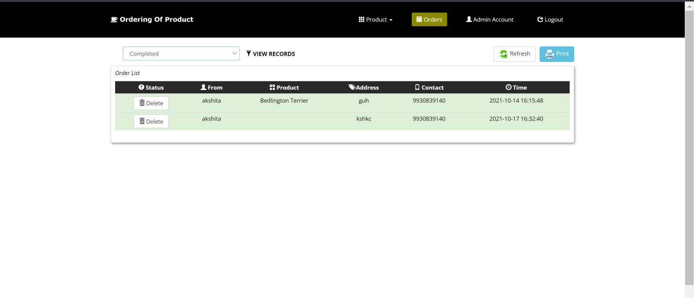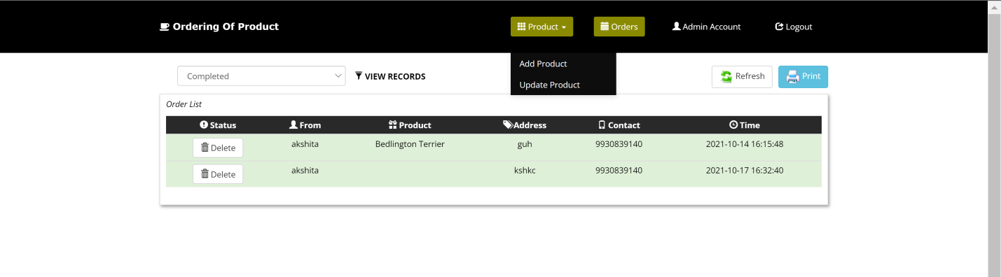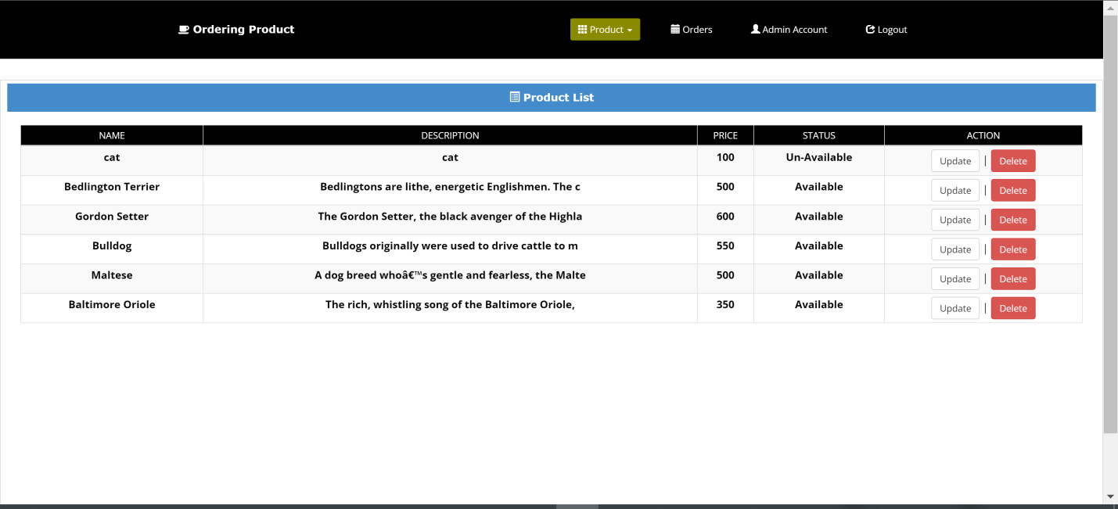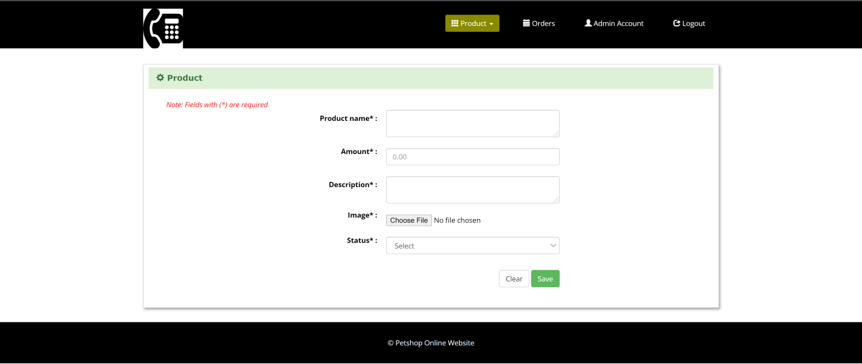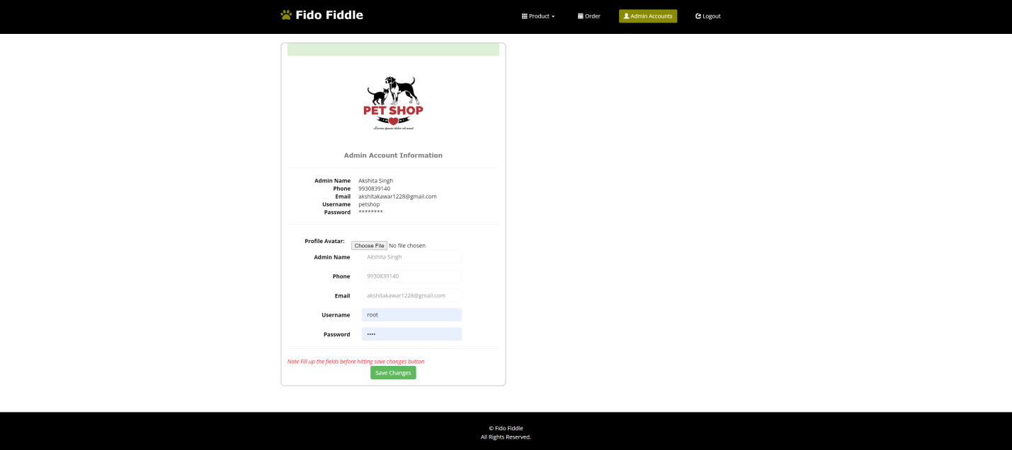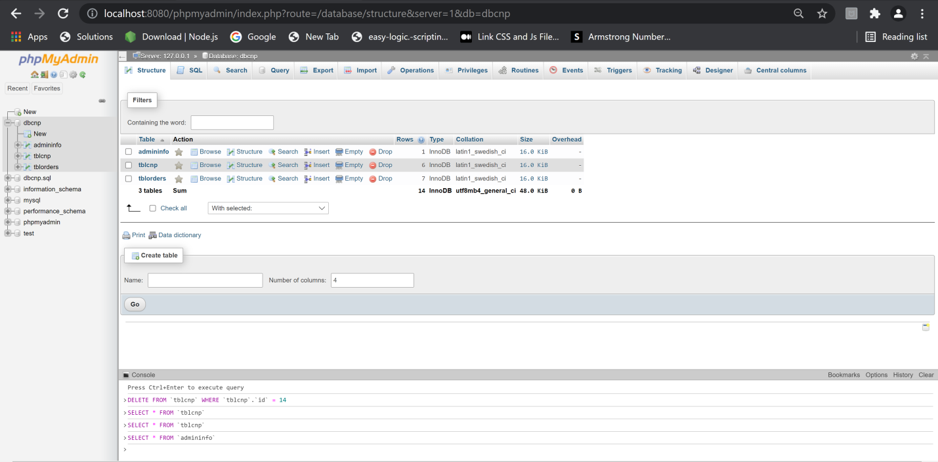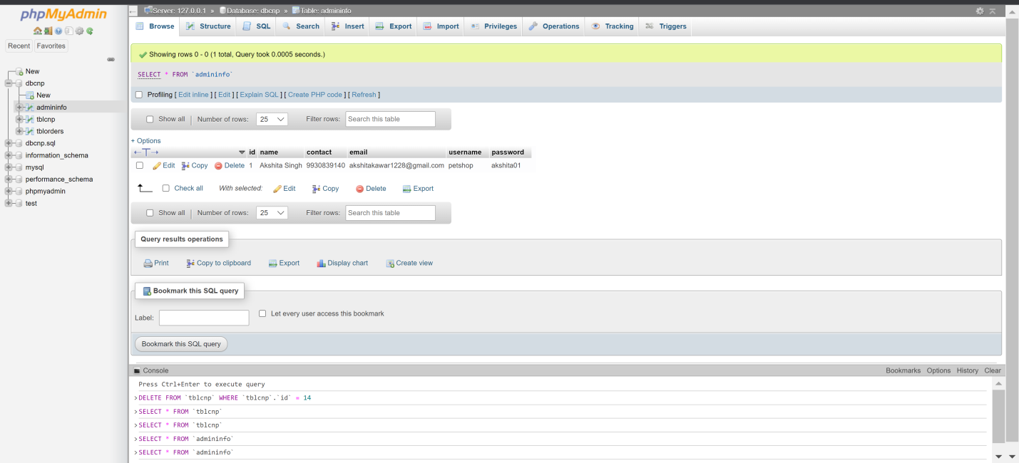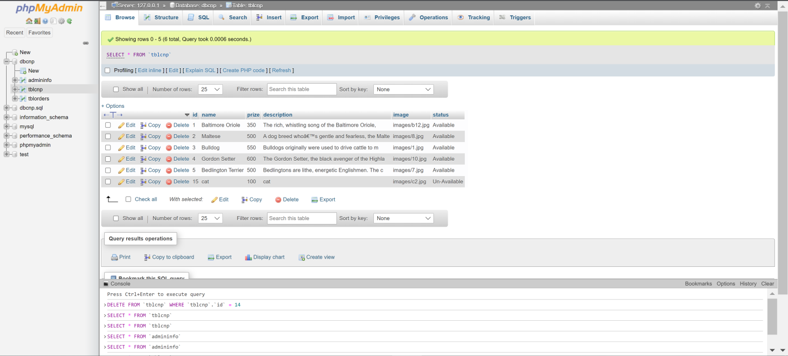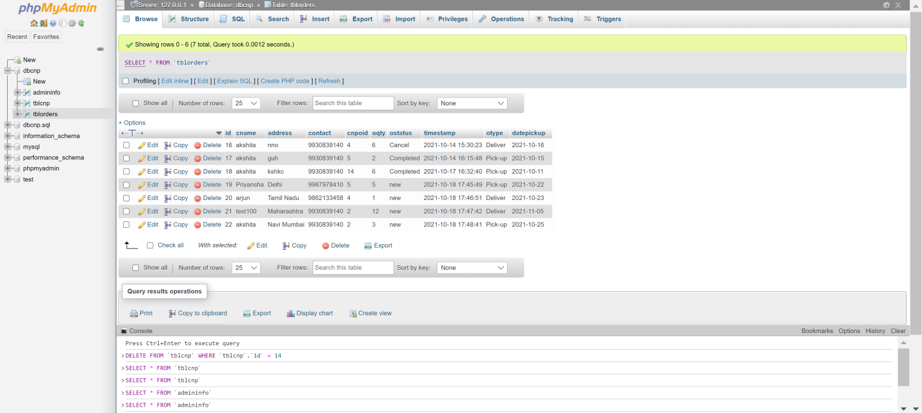

1. **Conclusion and Future Scope**

**Conclusion**

The Fido Fiddle (Online Pet Shop) as a project is not an exception. With developers working 24/7 this software improves and speeds up user’s buying experience and makes it convenient for the customers to buy pets and pet food online at lowest rates that to with proper information of the product and 100% authenticity.

The issues with the existing online systems which provide only text based interface and not graphical interface, mismanagement with product availability and offline reports is solved by our system itself. The option of viewing video before buying any product helps customer with the complete information of the product makes us more reliable in the market.

**Future Scope**

In India, there has been a steady rise in the sale of pet products and services over the past 2-3 years. However, the market still remains competitive and open, with new tech disruptions causing rapid shifts in the Indian pet market landscape. As per a report, the Indian pet food market is projected to cross $270 million by 2022. The growing per capital income plus the increasing pet ownerships in the urban areas has given way to many new businesses in the pet industry.

**A study conducted by Euro monitor International in 2015 showed the Indian pet-care market at Rs 1,394 crore – doubled from Rs 538 crore in 2011.**

Indian pet care market is expected to grow with a CAGR of more than 20% between 2018 and 2022.

According to industry experts, the market is open and there is growth in e-commerce in the pets and pet-accessories business. With India getting more and more urbanized, the market is set to grow and sustain. So, small businesses looking for opportunities in pet ecommerce industry in India will have an open market to establish themselves and get their piece of market share in the upcoming 3 to 4 years.

1. **Applications**
   * + - **Pet care homes/Ngo’s**
       - **Animal lovers**